VISUAL PROGRAMMING



VISUAL PROGRAMMING (CS284) BS – COMPUTER SCIENCE – FALL 23

SECTION –A

## NAME : FATIMA ROLL NO : 233519

**TASK : ASSIGNMENT 02 SUBMITTED TO : MAM ATKA ALI SUBMISSION DATE: 11/2/2024**

1

VISUAL PROGRAMMING

# ASSIGNMENT : 02

**Run and Test the Windows Form Controls**

# 1. Button Control:

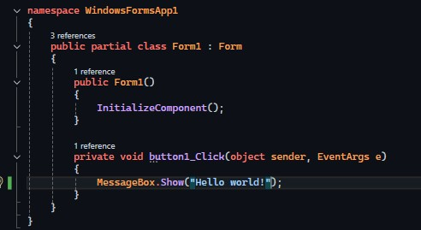

HELLO WORLD!

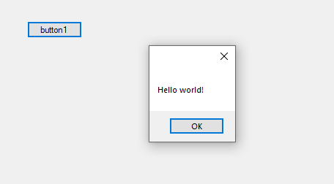

2

VISUAL PROGRAMMING

“HELLO WORLD! , HELP”:

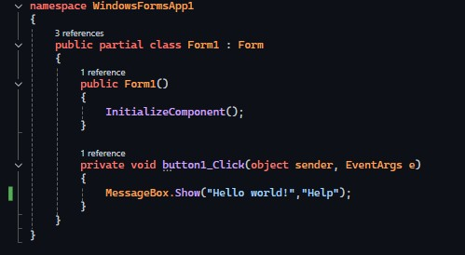

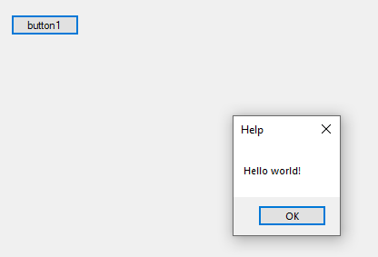

## DEMONSTRATION OF MESSAGE BOX CLASS MEMBERS :

1. **“OKCancel”:**

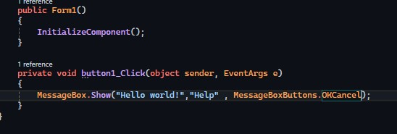

3

VISUAL PROGRAMMING

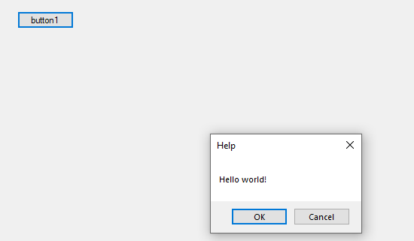

1. **“YESNO”:**

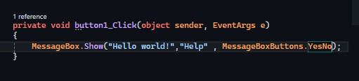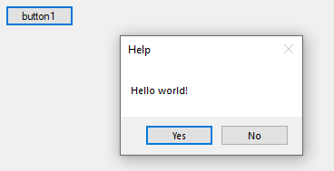

1. **“AbortRetryIgnore”:**

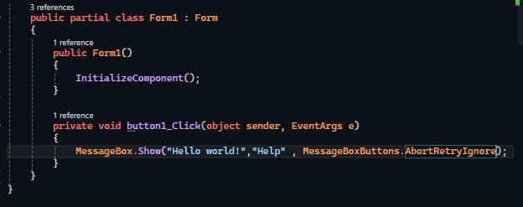

4

VISUAL PROGRAMMING

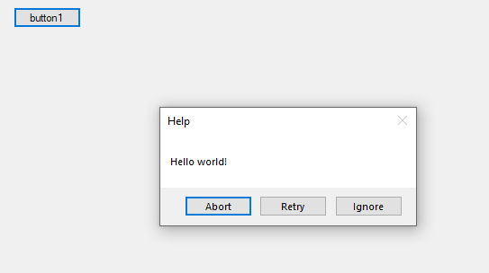

* **USING “INFORMATION” ICON:**

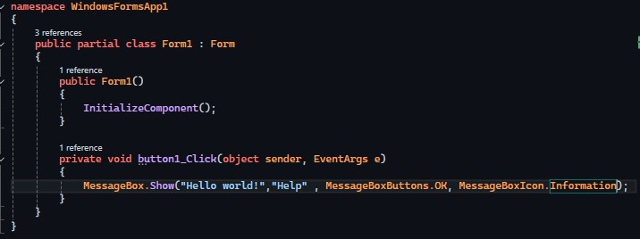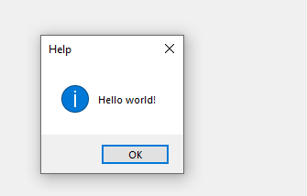

* **CLICKING BUTTON:**

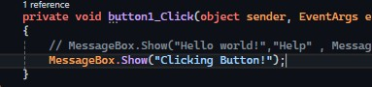

5

VISUAL PROGRAMMING

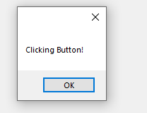

# LABEL CONTROL:

CREATING A SIMPLE LABEL:

**1**.

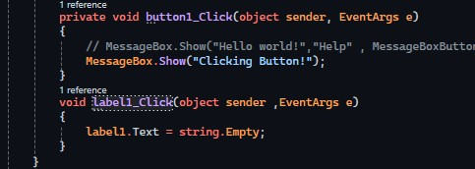



2.

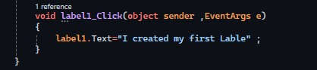

6

VISUAL PROGRAMMING

# TEXTBOX CONTROL:

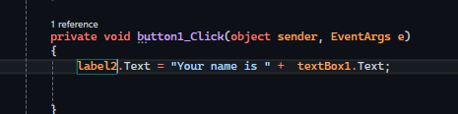

* **Created a label : “Enter Your Name”**
* **Created a Button called “Done”**

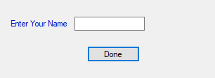

Created a textbox where name is written

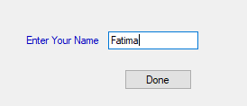

Created another label to show your name e.g. “Your name is Fatima” in this case.

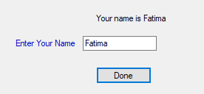

7

VISUAL PROGRAMMING

Example no : 02( of textbox)

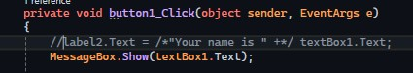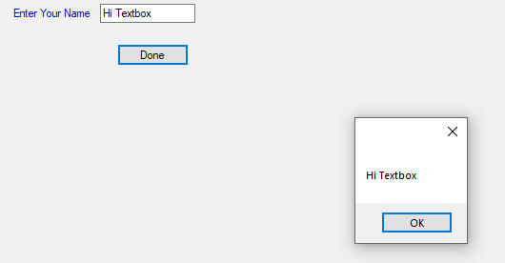

# RichTextbox Control:

First created three buttons for Bold, Italic and UnderLine.

8

VISUAL PROGRAMMING

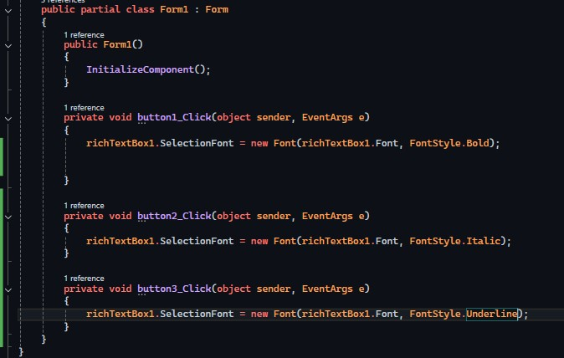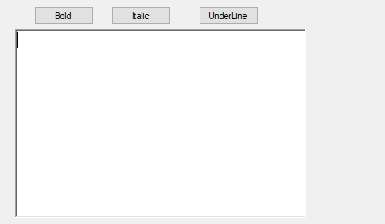

Normal Text:

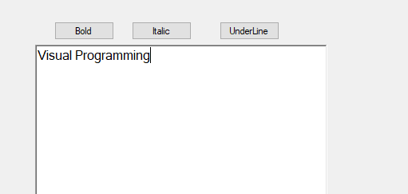

9

VISUAL PROGRAMMING

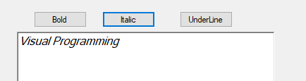

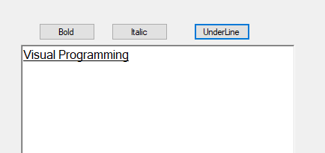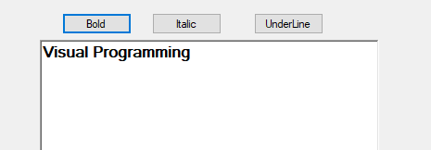

* **Demonstration of Bold , Italic and UnderLine buttons.**

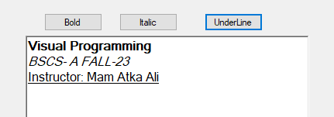

10

VISUAL PROGRAMMING

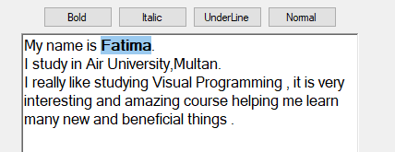

Created another button for normal text , to retransform the text into normal form.

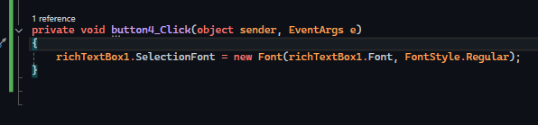



Code Implementation:

11

VISUAL PROGRAMMING

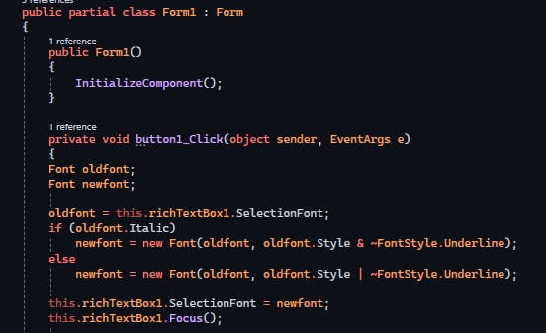

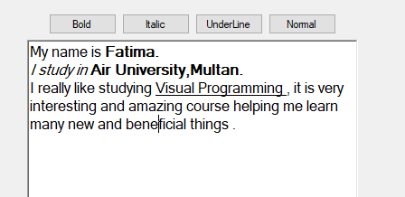

Shape

# Checkbox Control:

Code Implementation:

12

VISUAL PROGRAMMING

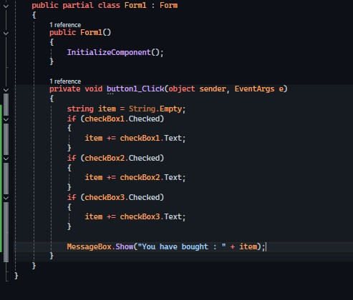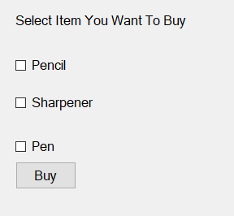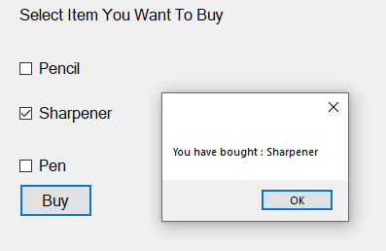

13

VISUAL PROGRAMMING

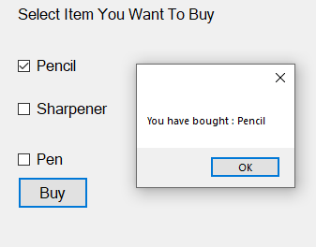

Shape

# Radio Button Control:

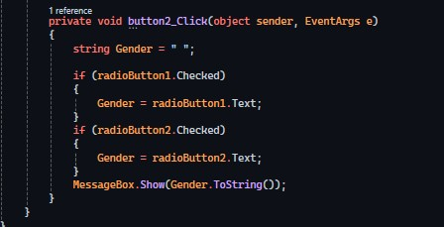

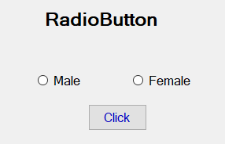

14

VISUAL PROGRAMMING

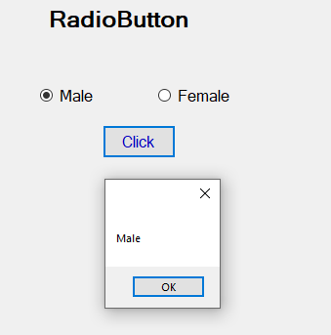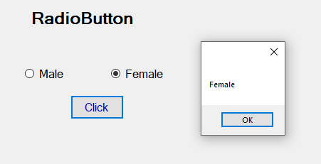

## Checkbox and Radio Button Control

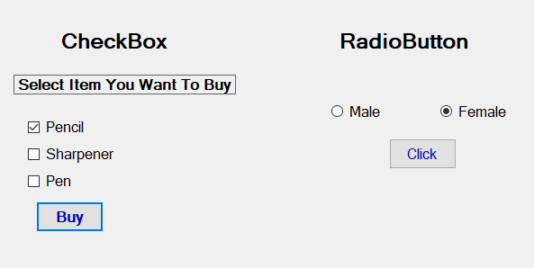

Shape

15

VISUAL PROGRAMMING

# Numeric Updown Control:

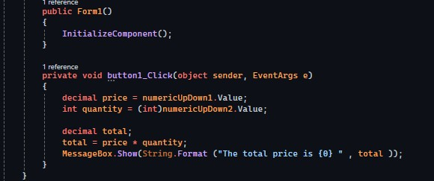

Calculating the total price by multiplying price with quantity

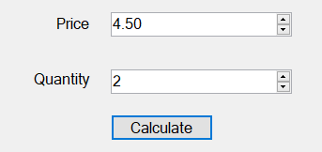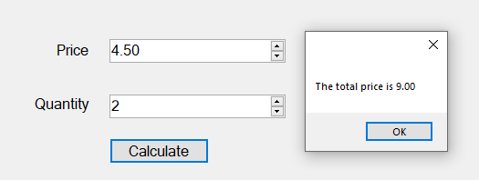

Shape

16

VISUAL PROGRAMMING

# Picture Box Control:

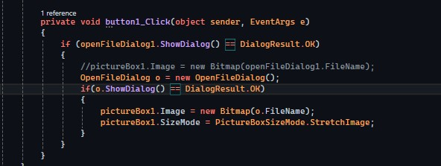

Originally Chosen:

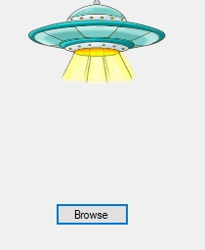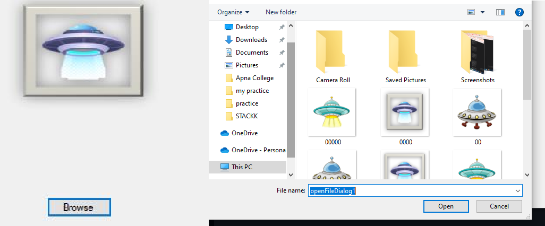

17

VISUAL PROGRAMMING

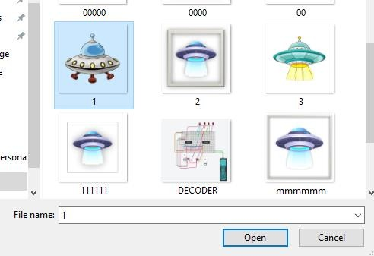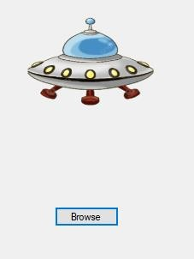

# Combo Box Control:

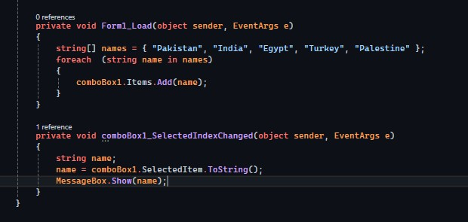

18

VISUAL PROGRAMMING

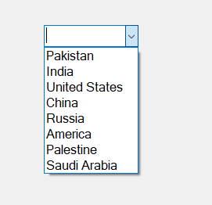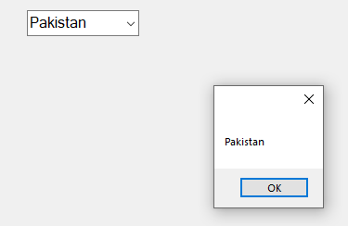

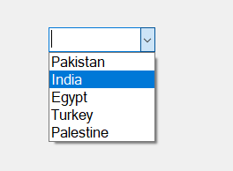

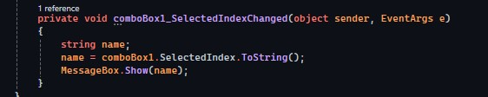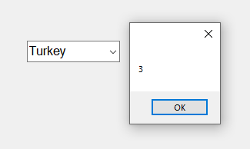

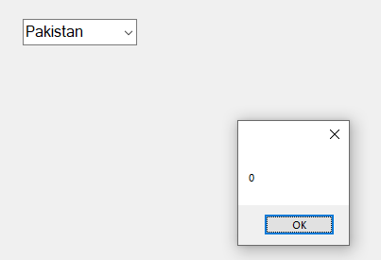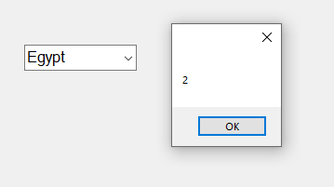

19

VISUAL PROGRAMMING

Combo Box 2 :

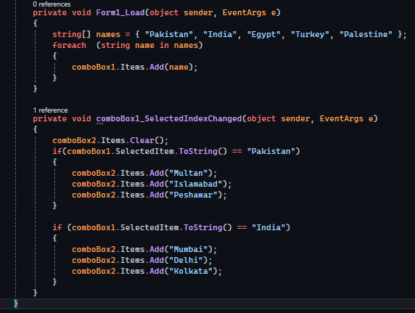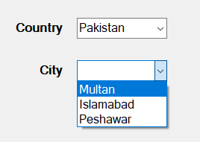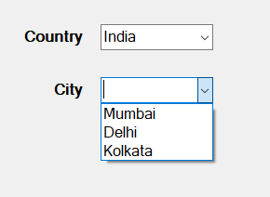

Shape

20

VISUAL PROGRAMMING

# Datetime Picker Control:

## Format

* **long**



* **short**

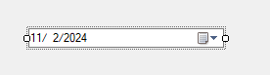

* **time**

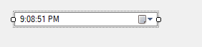

* **custom**

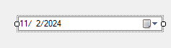

## CODE IMPLEMENTATION

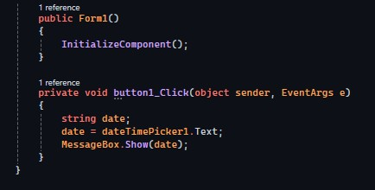

21

VISUAL PROGRAMMING

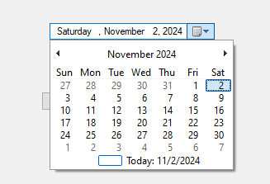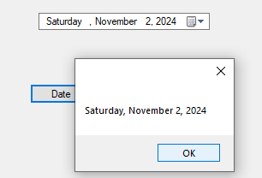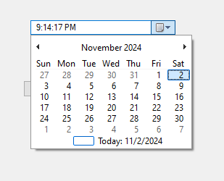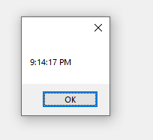

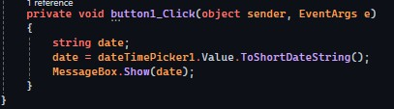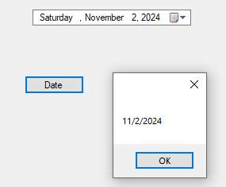

22

VISUAL PROGRAMMING

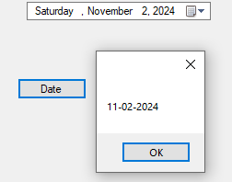



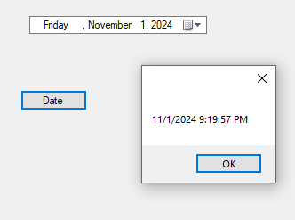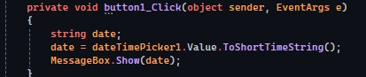

23

VISUAL PROGRAMMING

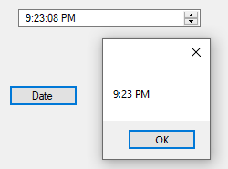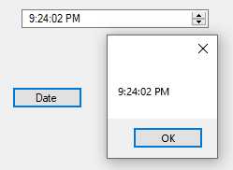

# Month calendar Control:

Dimensions:

3,1

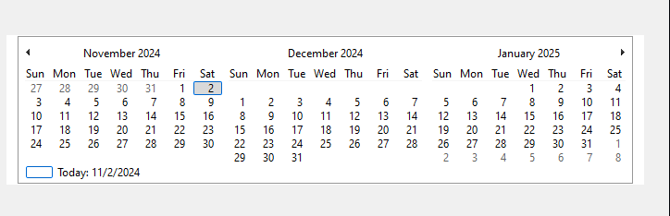

24

VISUAL PROGRAMMING

3,3

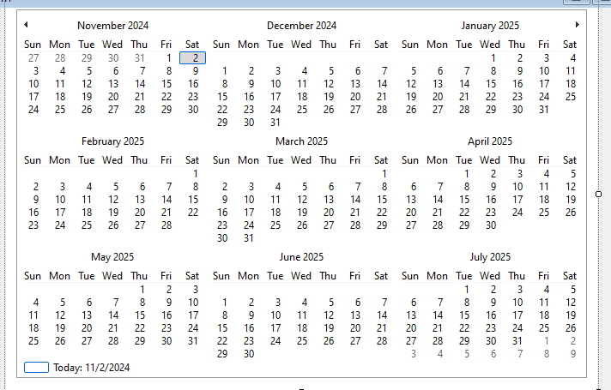

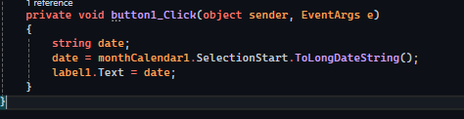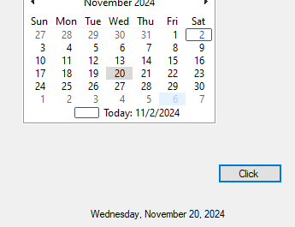

25

VISUAL PROGRAMMING

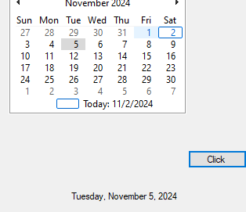

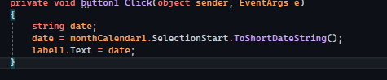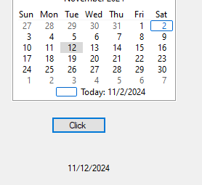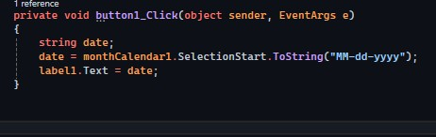

26

VISUAL PROGRAMMING

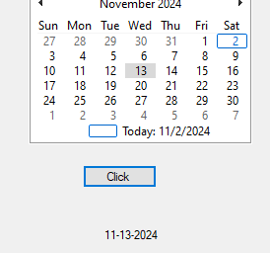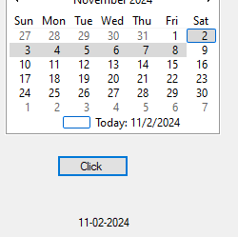

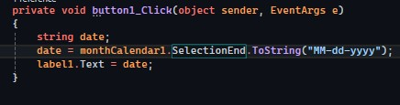

27

VISUAL PROGRAMMING

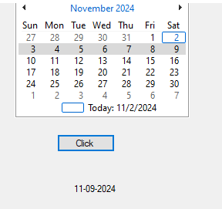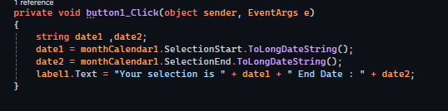

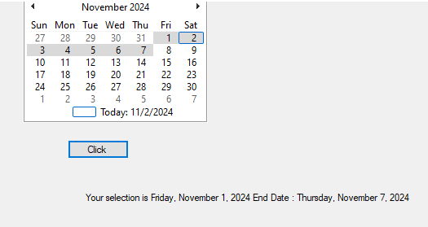

28

VISUAL PROGRAMMING

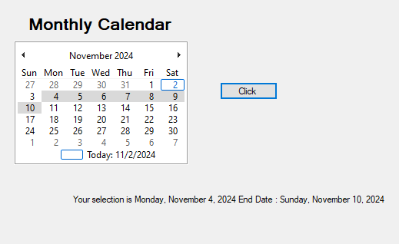

Shape

29